Ideation Phase
Define the Problem Statements
Date | 17 September 2026
Team ID | Individual project
Project Name | Employee Issue Management – Record Producer and Service Portal Integration
Maximum Marks | 2 Marks
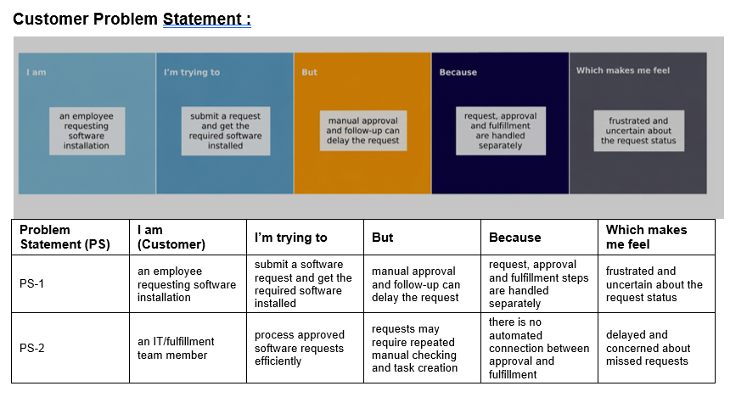

PS-1 – Employee / Issue Reporter

The customer is an employee who experiences a workplace issue (payroll discrepancy, access problem, infrastructure request, or HR policy clarification) and needs a timely resolution to perform daily work efficiently. The employee is trying to submit an issue report and obtain resolution through a single, reliable process.

However, informal communications and manual handling delay the request, especially when the employee must wait for support teams to manually triage and assign the issue. The employee often needs to contact the support team repeatedly via email or phone to find out whether the ticket has been picked up or assigned to a technician. This problem occurs because issue intake, field validation, prioritization, and team assignment are handled in disjointed manual steps rather than through an automated end-to-end workflow.

As a result, the employee feels frustrated, unproductive due to work disruptions, and uncertain about the ticket status. A structured Service Portal Record Producer with dynamic validations and real-time tracking provides clear visibility and eliminates unnecessary follow-ups.

PS-2 – Support / Assignment Team Member (IT, HR, Payroll, Facilities)

The customer is a support team member or assignment group agent (IT, HR, Payroll, Facilities) responsible for triaging and resolving reported workplace issues. The team member is trying to process issues efficiently, gather all necessary intake data upfront, prioritize urgent cases, and route tickets to the correct team.

However, incoming requests often arrive missing critical details, requiring repeated back-and-forth communication and manual checks, which significantly increases the support team's workload. Team members must manually verify request details, determine priority levels, assign the ticket to the correct group, and update status logs. This happens because there is no automated connection between the intake form (with enforced field dependencies and validations) and backend assignment logic.

When issue volume increases, these manual tasks create bottlenecks and heighten the risk of delays or missed tickets. As a result, the support team member feels overwhelmed and concerned about missed service level agreements (SLAs). Automated business rules, UI policies, and data policies streamline intake, auto-calculate priority, route issues to the proper assignment group, and ensure structured ticket lifecycle management.

